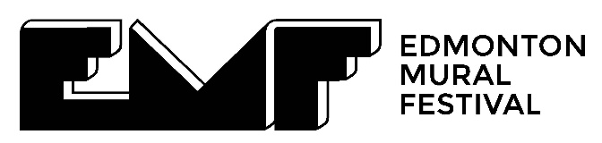

Dear Award Committee,

It is with great enthusiasm that I write to nominate Branden Cha (“Busyrawk”) for the 2025 Eldon + Anne Foote Edmonton Visual Arts Prize.

As the Executive Director of The Edmonton Mural Festival, I have had the privilege of witnessing firsthand the profound impact of Busyrawk’s work on our community. Specifically, his piece Azure Dragon of the East, exemplifies the power of public art to bridge cultural divides and foster a deeper understanding among diverse communities.

Murals hold significant importance in the context of visual art practice in Canada. Unlike works displayed within the confines of traditional galleries, murals are inherently public and permanent. They transform urban landscapes into accessible art spaces, democratizing the experience of art and making it a part of daily life for all who encounter it.

This mural, situated in Edmonton’s Chinatown neighbourhood, is a vivid example of how public art can serve as both a mirror and a beacon, reflecting our shared history and identities while inspiring future dialogue.

Why this work has been nominated above all other eligible works

This work was unique in its ability to bring together visual elements from diverse communities, and leverage that visual artistry to bring together members from the Chinese, Indigenous, and broader communities in a collaborative and meaningful way.

From conception to completion, Busyrawk engaged with these communities, listening to their stories, incorporating their histories, and weaving their shared narratives into a visual masterpiece. The result is a work of art that does not merely exist in public space but transforms it - a living testament to the shared values and experiences of our city’s multicultural fabric.

At the Edmonton Mural Festival, we champion art that transcends boundaries—both physical and cultural. Azure Dragon of the East embodies this ethos, and its impact extends far beyond its stunning visuals. By engaging and informing community members throughout the series, and through the celebration of this work in particular, the mural fosters a sense of ownership, pride and responsibility. It stands as a shining example of how public art can not only beautify our cities but also unite and inspire the people who call them home.

I firmly believe that the Azure Dragon of the East mural deserves recognition for its artistic excellence, and its role in demonstrating the power of public visual art in Edmonton.

Thank you for considering this nomination. Please feel free to reach out if you require any additional information or materials to support this application.

Sincerely,
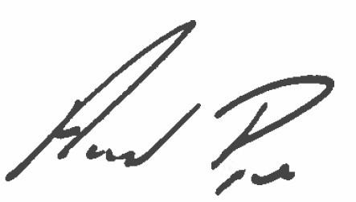
Anand Pye
Executive Director
Edmonton Mural Festival

About the work

The Azure Dragon of the East by Branden Cha (“Busyrawk”) is a 1,908-square-foot aerosol mural on concrete, completed in 2024 as part of a four-part multimedia mural series in Edmonton’s Chinatown. This project declares Chinatown as a neighborhood of inclusion that comes with shared responsibilities.

The work addresses the legacy of exclusionary legislations such as the Chinese Exclusion Act and the Head Tax, which birthed this neighborhood, re-imagined as one of belonging. The work emphasizes upholding treaty promises to support our unhoused community members and address resource inequities.

While the mural is highly visible, it also served as an intersection converging a diverse team of collaborators. The Chinese poem featured on the mural, written by local poet Stephen Tsang and stylized in calligraphy, reads:
"The Azure Dragon soars in Chinatown’s skies,
Guiding us to a future where all boats rise.
Honor the land and uphold treaty,
The flow of culture will bring prosperity."

This poem encapsulates the mural’s message of inclusion, shared responsibilities, and cultural resilience. A QR code was painted onto the mural, linking to a seven-minute cinematic film directed by Jordon Hon and Intertwined Studios, which served to fully communicate the themes with the general public. Screen captures from the film are included in the compilation of digital images for this submission.

The mural unveiling on September 28, 2024, was a landmark community event that featured an innovative projection mapping display by Sokaris Studios. This dynamic light installation brought the mural to life, merging traditional artistry with cutting-edge technology. A round dance led by Chubby Cree, symbolizing unity, reconciliation, and the coming together of diverse communities, was also held during the celebration.

Through months of collaboration with Chinatown poets, artists, Indigenous elder, and community members, the mural amplifies voices historically excluded from mainstream narratives. It honors the sacrifices of early Chinese immigrants, addresses the legacy of exclusionary legislations, and upholds treaty obligations to Indigenous peoples, particularly amidst ongoing struggles for housing and resource equity.

The Azure Dragon of the East stands as a beacon of cultural resilience, uniting art and community engagement to foster dialogue, understanding, and solidarity while preserving Edmonton Chinatown’s identity in the face of modern challenges.

